TEST STATISTICS:

A **test statistic** is a random variable that is calculated from sample data and used in a hypothesis test. You can use **test statistics** to determine whether to reject the null hypothesis.

HYPOTHESIS TEST:

The **purpose of hypothesis testing** is to determine whether there is enough statistical evidence in favour of a certain belief, or **hypothesis**, about a parameter.

* Null hypothesis(H0 )
* Alternative hypothesis(H1 or HA )

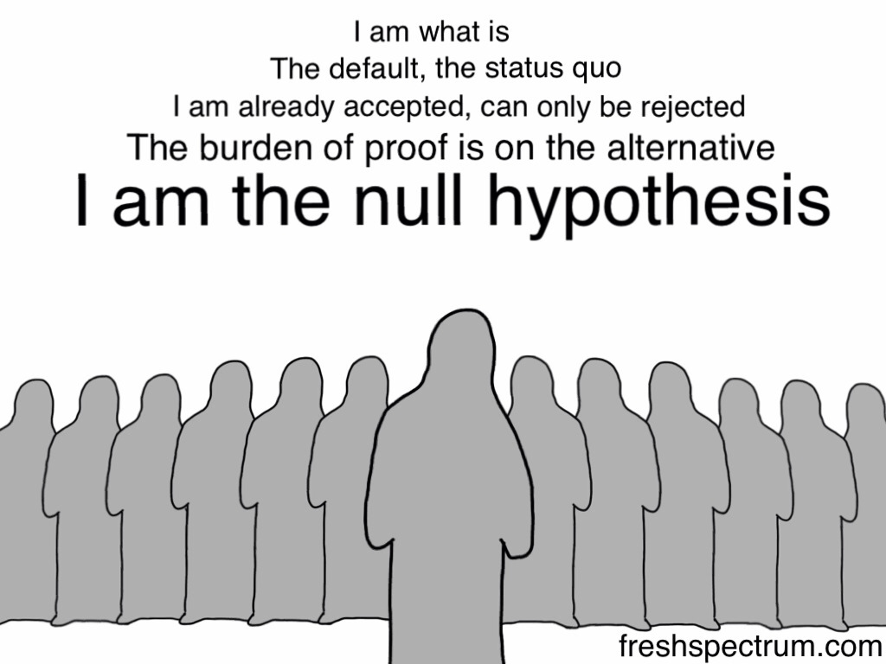

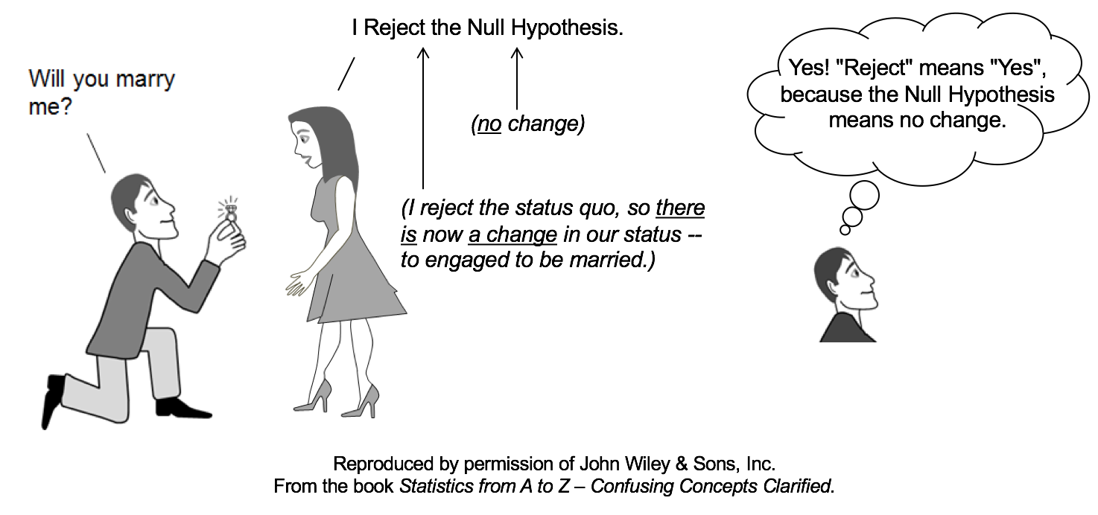

CRITICAL REGION UP CLOSE:

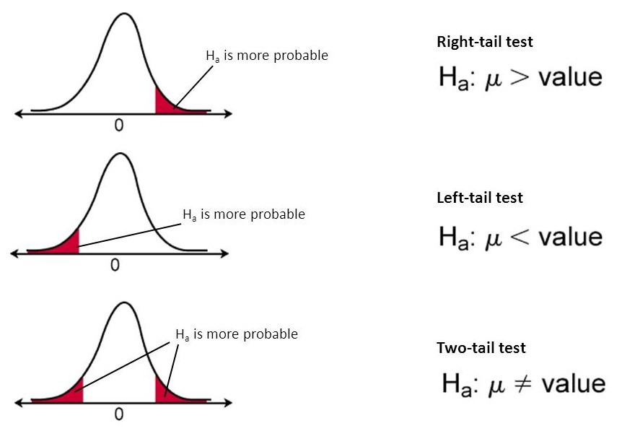

COMMON TEST STATISTICS FOR INFERENTIAL TECHNIQUE:

1. Related to sampling distribution of mean

* Z test
* T test

1. Related to sampling distribution of variance

* Chi squared test
* F test

Hypothesis testing steps:

1. State the null and alternate hypothesis
2. Chose the level of significance
3. Find critical values
4. Find test statistics
5. Draw the conclusion

Z TEST:

 A **z**-**test** is a statistical test used to determine whether two population means are different when the variances are known and the sample size is large.

Formula:

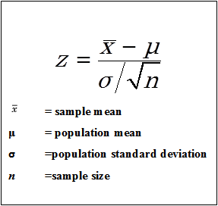

Assumptions:

1. Sample size should be greater than 30
2. Population standard deviation should be known
3. Variable should be continuous.

T test:

A t-test is a type of inferential statistic used to determine if there is a significant difference between the means of two groups, which may be related in certain features. It is commonly called as students t test.

Formula:

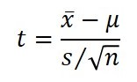

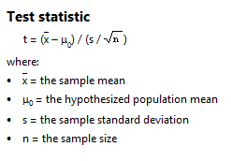

Assumptions :

1. Sample size less than 30
2. Population standard deviation is not known
3. Variables should be continuous

NOTE:

IF THE POPULATION STANDARD DEVIATION IS NOT KNOWN GO FOR T-TEST WITHOUT CONSIDERING THE SAMPLE SIZE